The American State Bank was located in Kearney, NE. According to the Kearney Hub (12/31/1918) it was located at 22nd and Central Avenue. It opened in 1917 and closed in 1929 (Hub: 6/12/2015). In 1929 it was changed to Fort Kearney State Bank. Then in 1939 it became the First National Bank. Following this it became First National Bank and Trust Co. in 1974. The name was changed to Wells Fargo in 2000 (Hub: 10/1/2000)

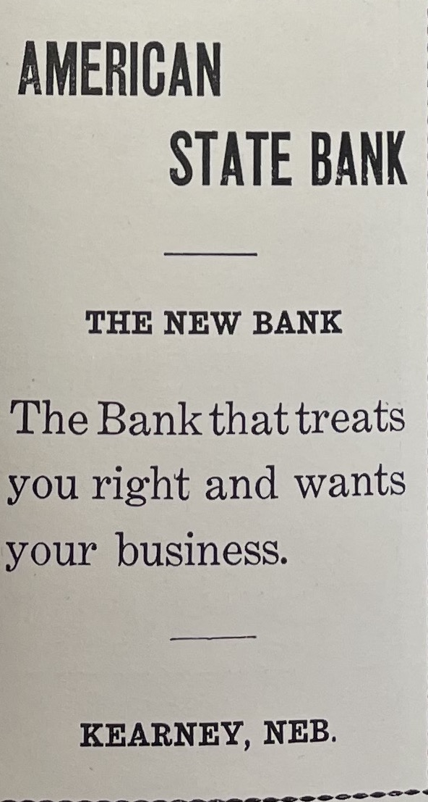
(Echo: Nov. 1919)

