The S.A.D Henline Druggist was located in Kearney, NE at 22nd and Central Avenue. Its advertisement can be found on the World Theatre curtain.

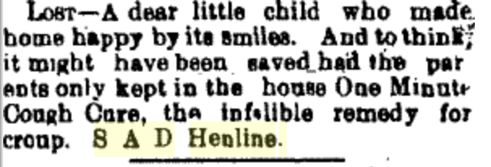
(Hub: 1/20/1897)
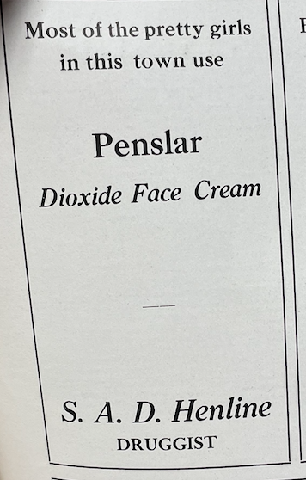

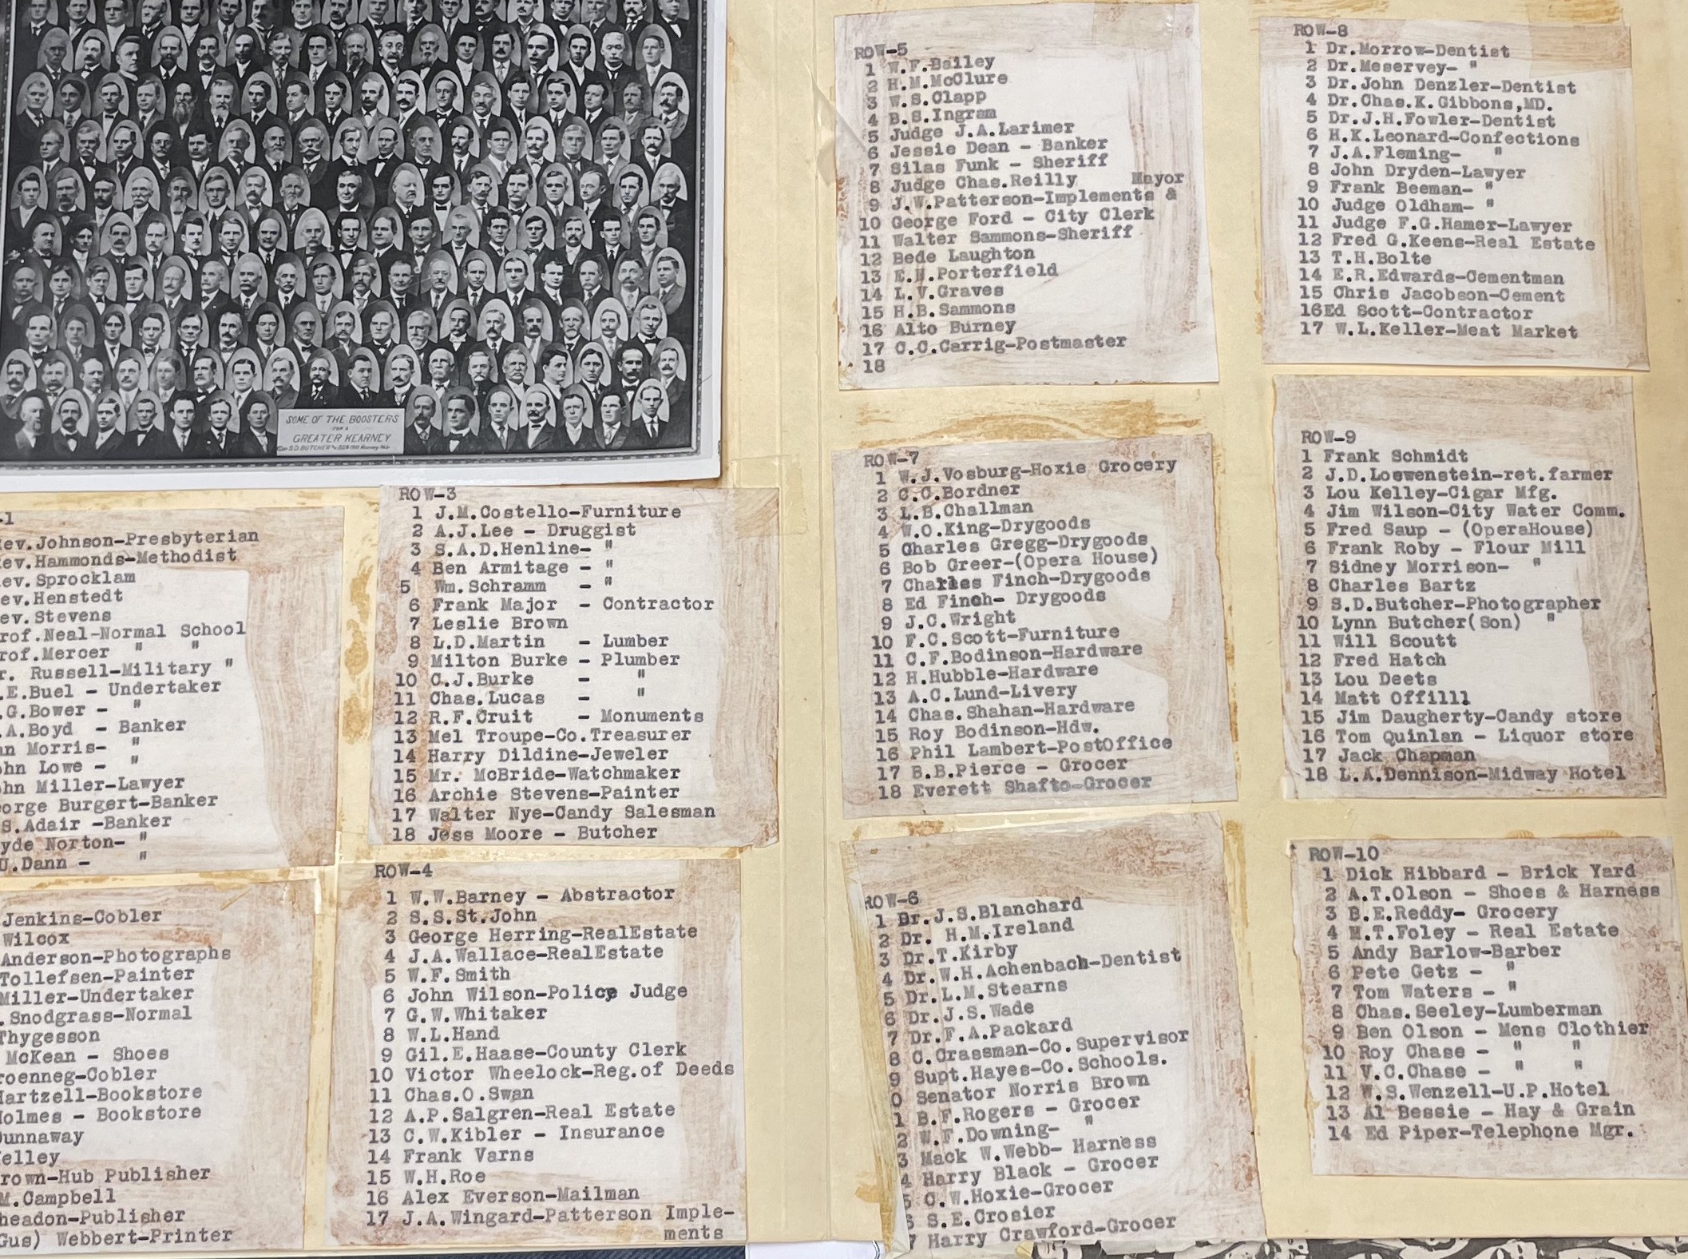
(Henline was listed as a part of the 1910 Boosters in Kearney)

