The Fertilizer and Chemical Supply was located in Kearney, NE. According to the Kearney Hub (5-19-1949) the business resided at 16 E R.R. St. Its advertisement can be seen on the Poole School curtain.
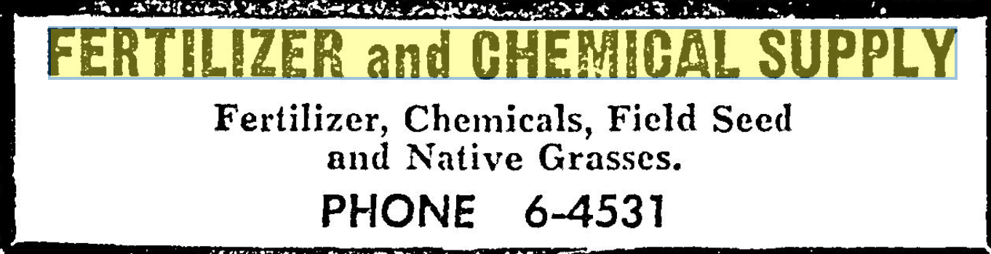
(Hub: 2-2-1959)

