F.C. Scott and Son was a furniture business located in Kearney, NE. It was owned by F.C. Scott and his son, C.P. Scott. Their advertisement can be seen on the World Theatre curtain.
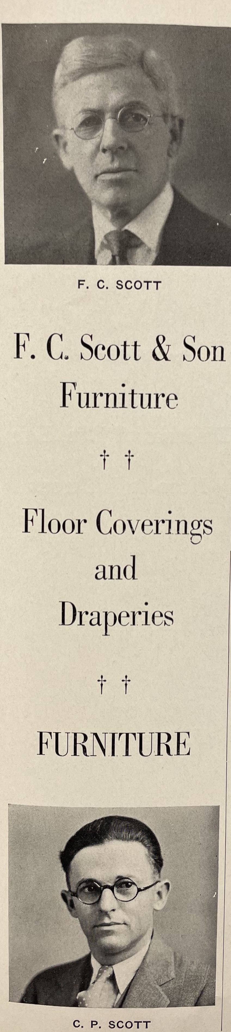
(Blue and Gold: 1933)

