The Red Top Cabin Camp was located in Elm Creek, NE. According to the Kearney Hub (10/5/2020), it was a, “Remnant of the heydays of the United States’ first coast-to-coast highways is being demolished…” The Red Top Cabin Camp is known for its red tile roof and for being a motel and campground along the Lincoln highway, or Highway 30. There were an astonishing nine owners of this business. Norris and Minnie Stevens owned it between 1953-1956. Don Sturgeon was yet another owner. Following him was the final owner, Larry Gydesen. Other owners included: Murl Watson, Bull TenEyck, Gail Taylor, and Clarence Hays and Walter Garringer. Because of I-80 being created in 1974, the Red Top Cabin Camp eventually lost business and succumbed to the interstate system.
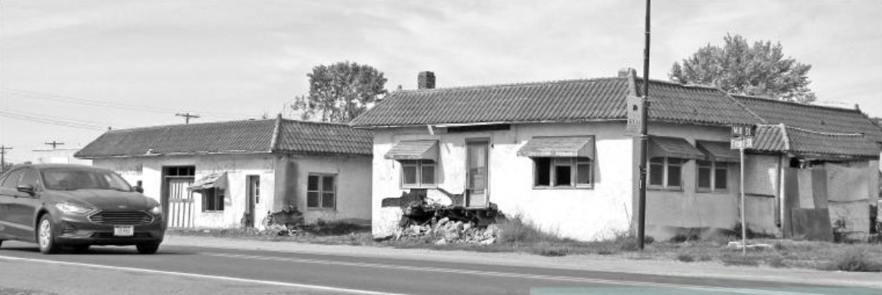
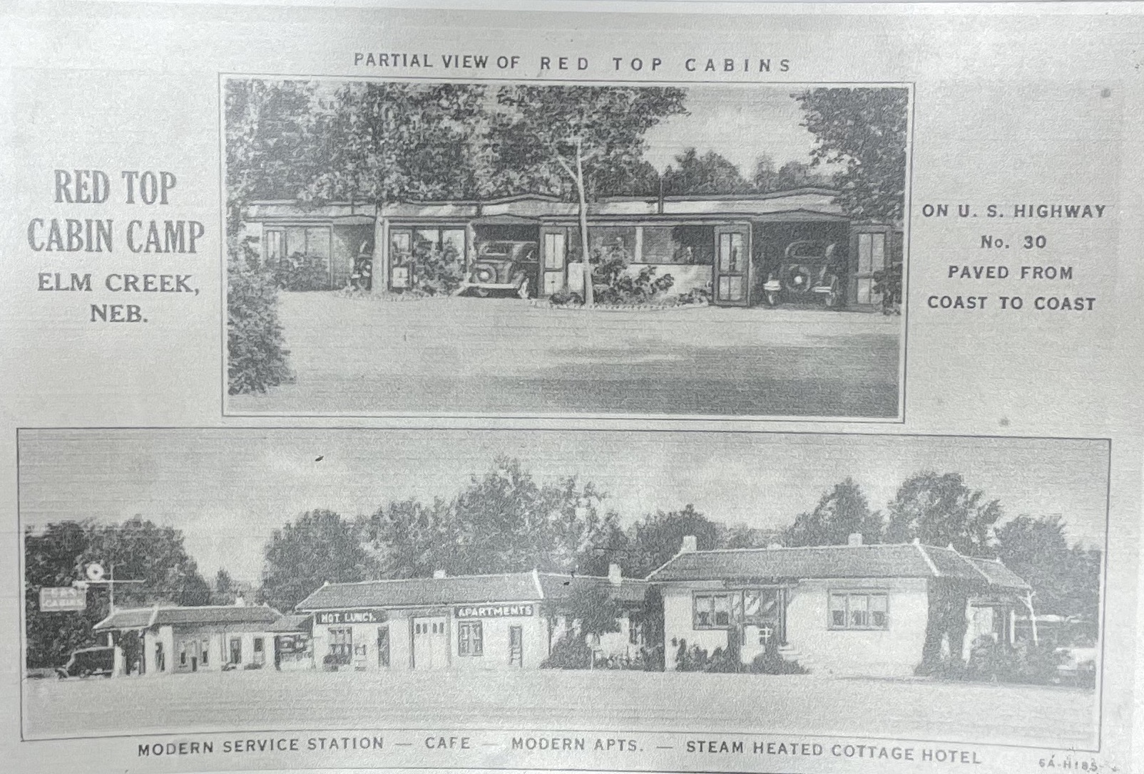 (BCHS Archives)

