C.F. Bodinson Hardware Company was located in Kearney, NE at 2120 Central Avenue. According to the Kearney Hub, (4-3-64) C.F. Bodinson was an immigrant from Sweden and attended Kearney State Teachers College. C.F. Bodinson began the business in 1878 and ran it as a grocery store before turning it into a hardware store. Roy Bodinson, his son, took over when his father died. During World War I, there was a boost in business as industry increased. Roy died in 1925 and his brother, Frank Bodinson took over until 1945. Waldo Bodinson (their cousin) then took over the family business until 1964.
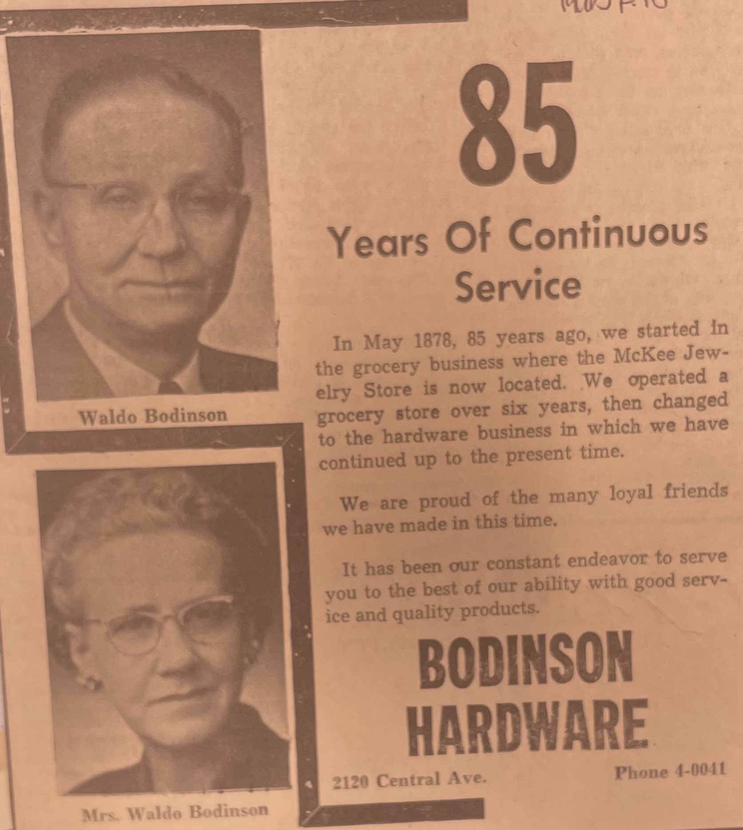
(Hub: 1963)
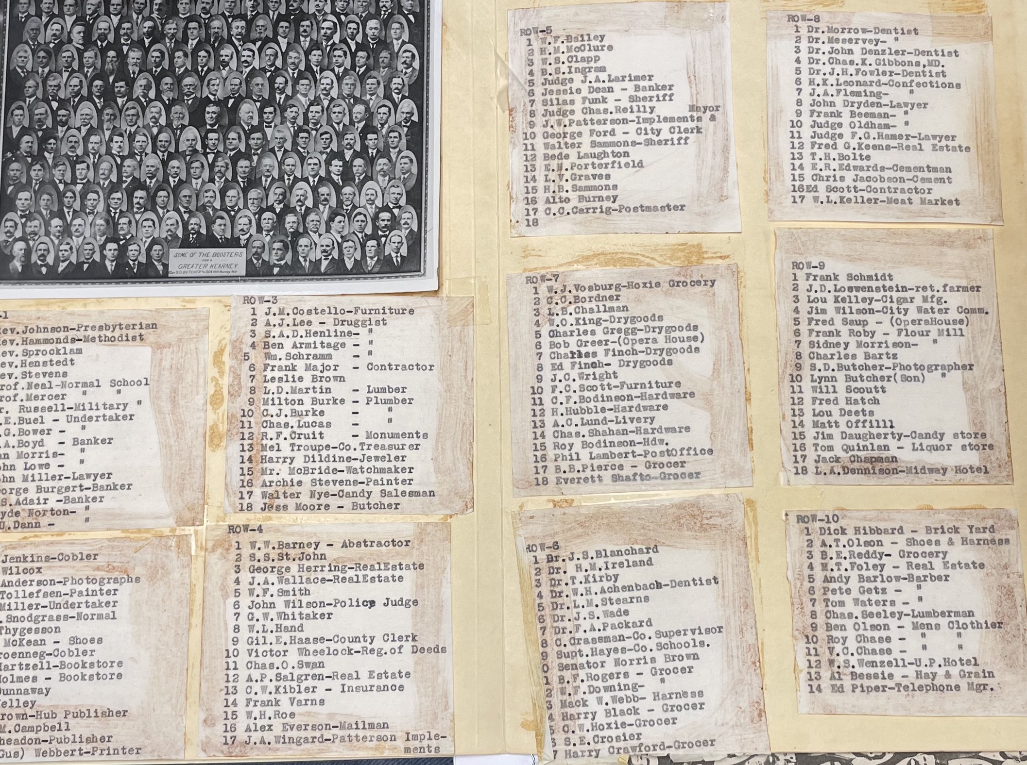
(C.F. and Roy Bodinson on the 1910 Kearney Booster’s list)
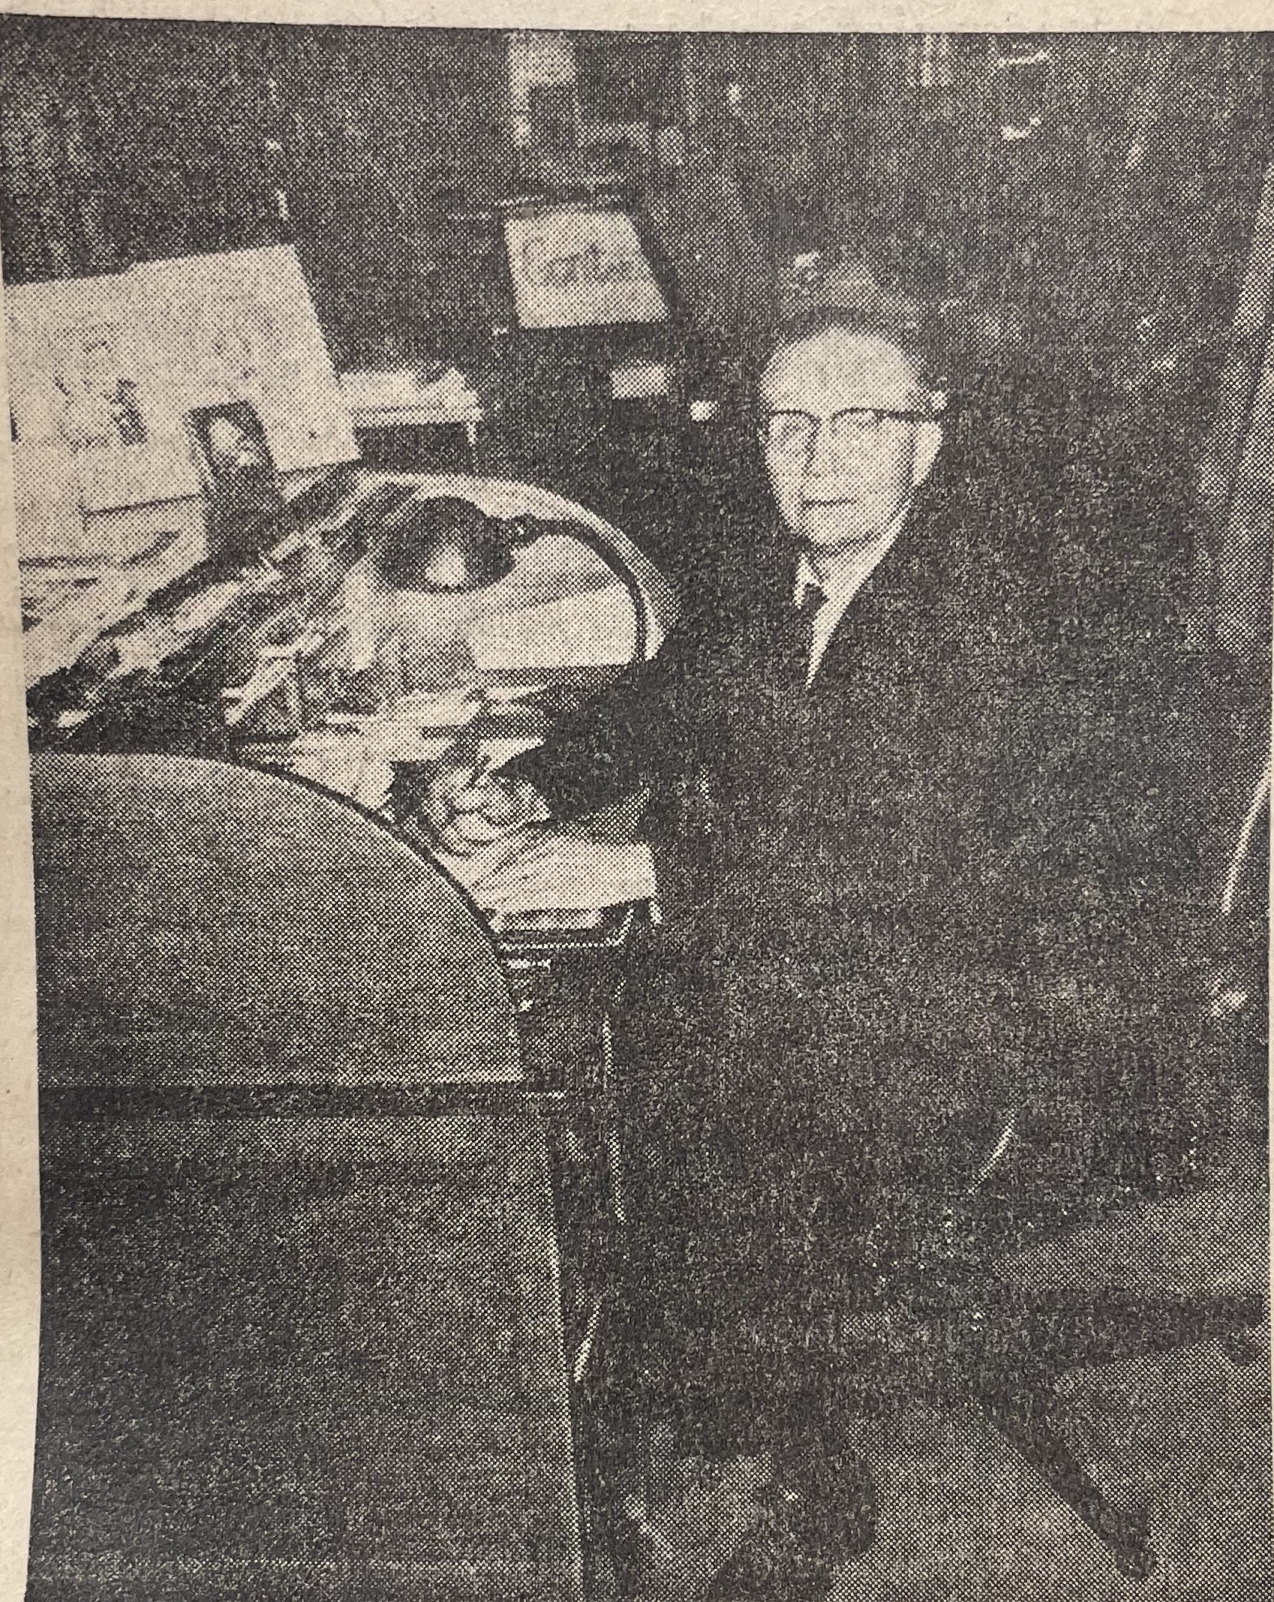
(Waldo, 1945)

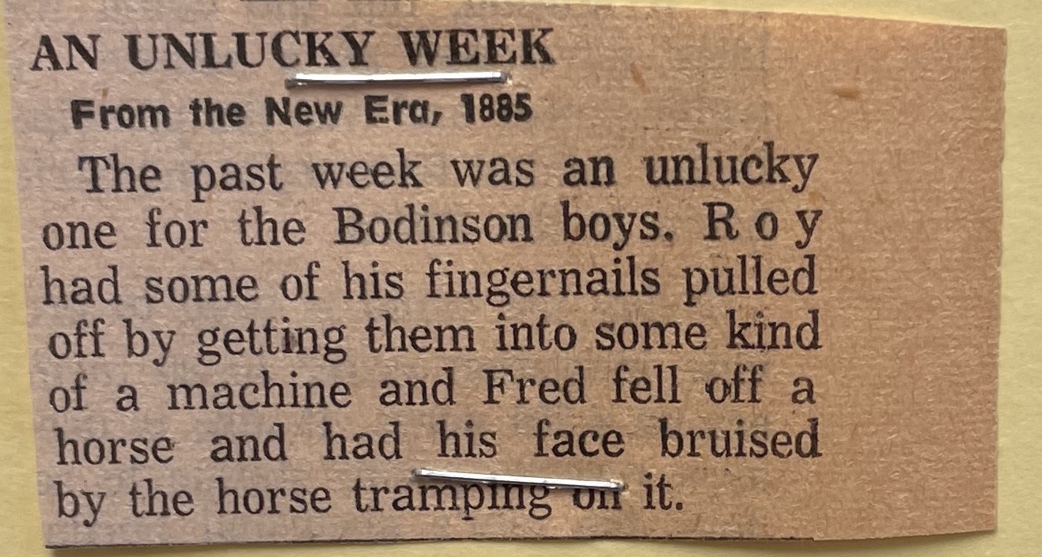
(1885)
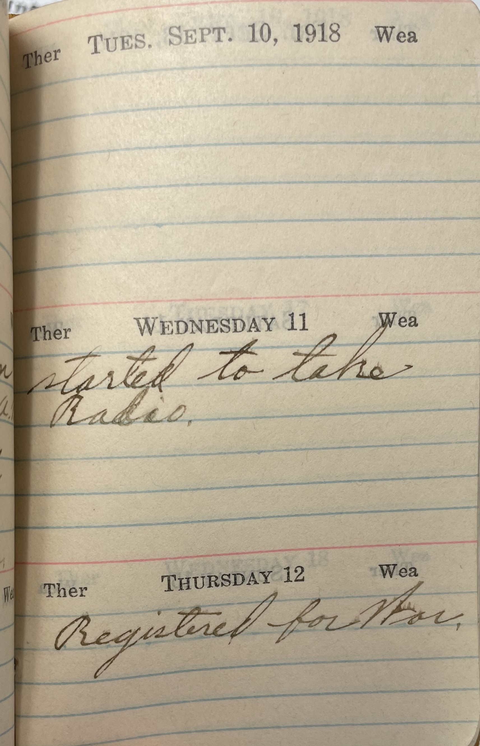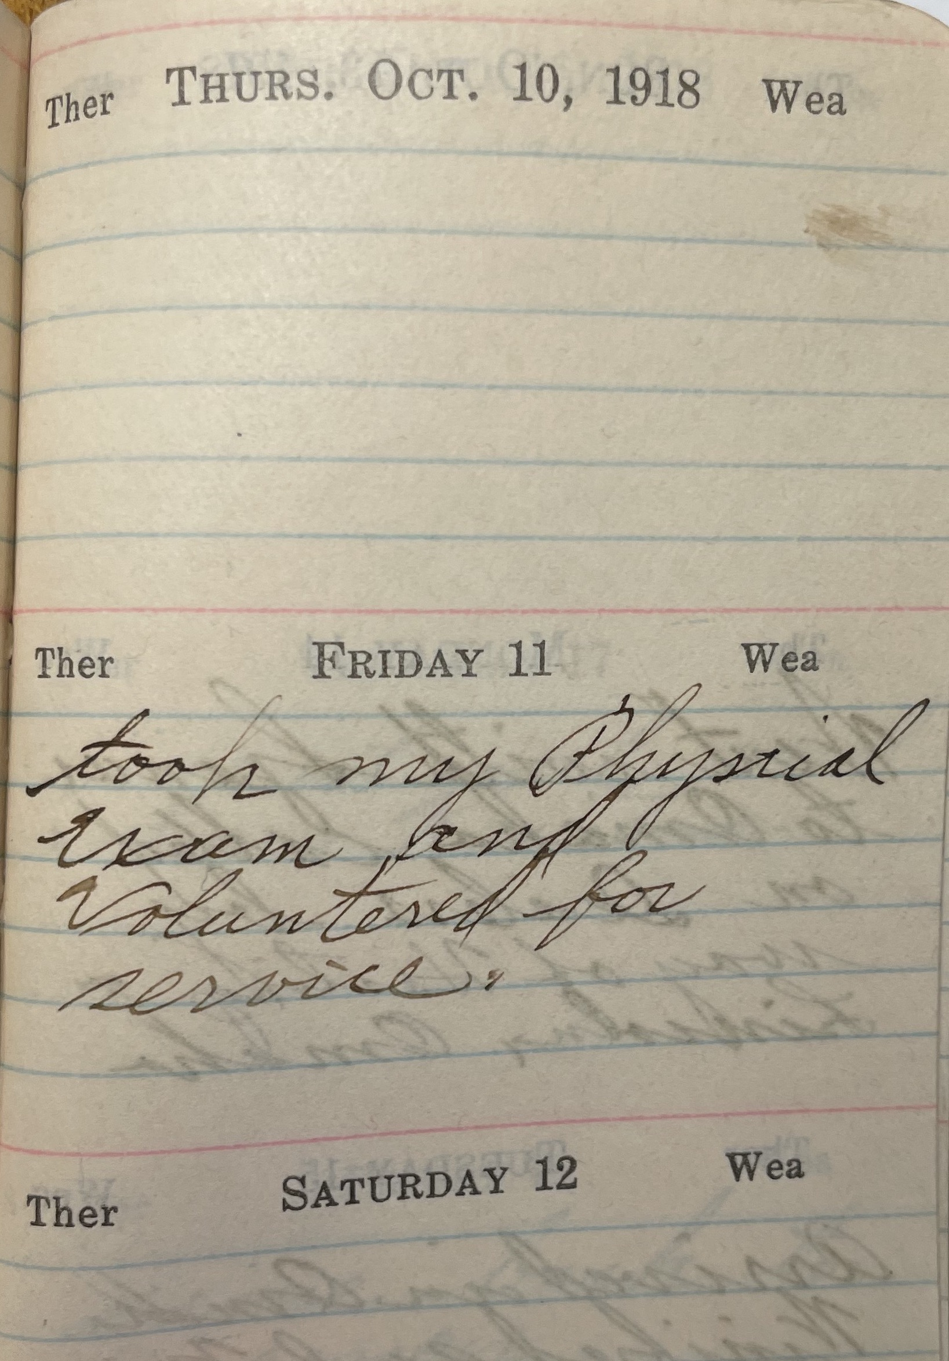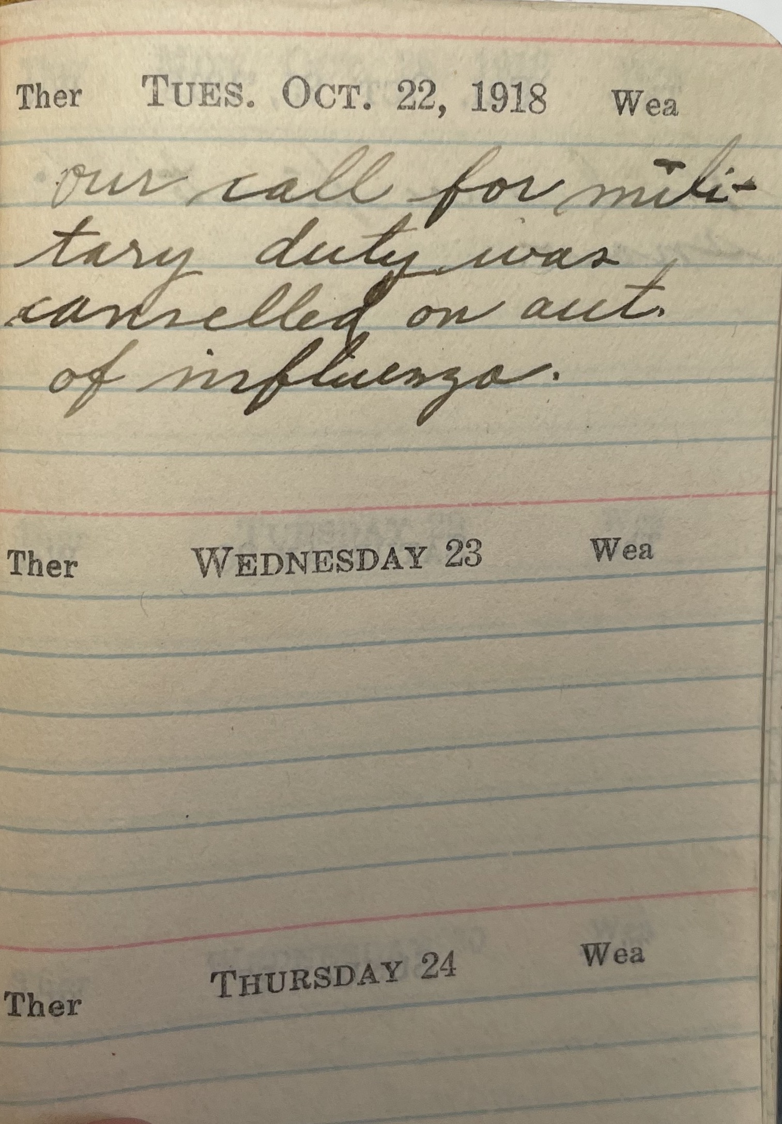
(Waldo Bodinson’s journal depicting registering for WWI, taking the physical, and the cancellation of active duty due to the Spanish Influenza)

