E.A. Eck Wallpaper was a business located in Kearney, NE. It was located 2215 Central Avenue and was originally established in 1892. Its advertisement is located on the World Theatre curtain.

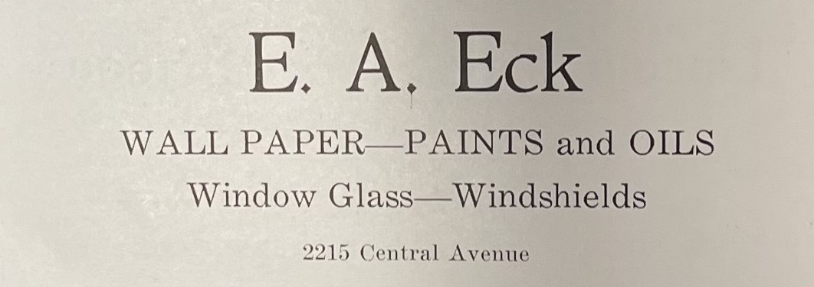
(Log: 1927)

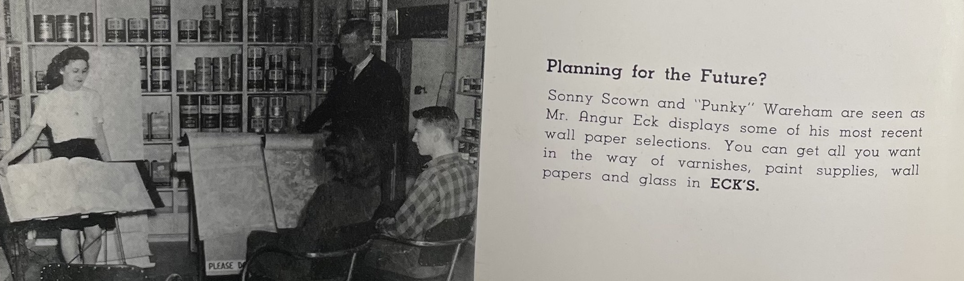
(Log: 1947)
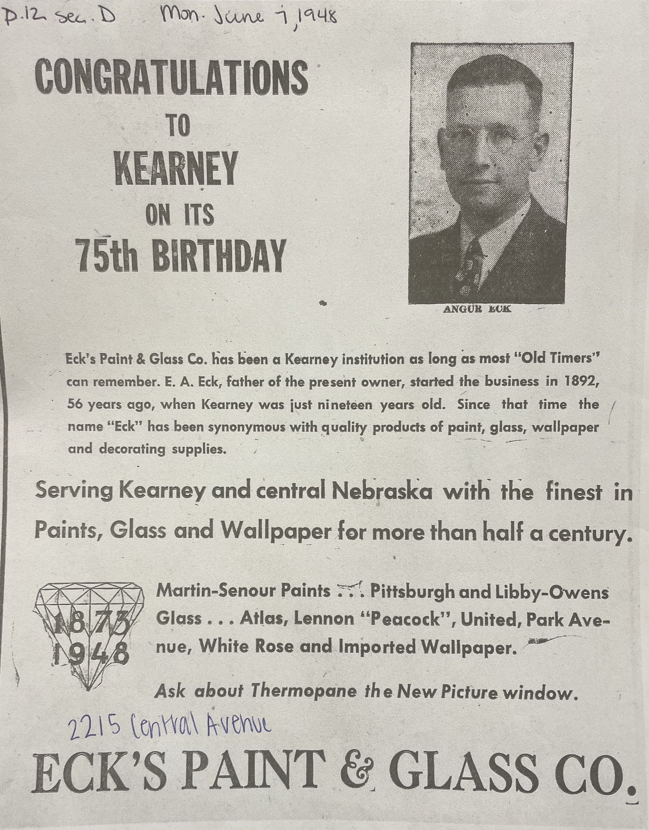
(Hub: 6/7/1948)

