The Boston Store was a general store located at 2010 Central Avenue in Kearney, NE. According to the Kearney Hub, (4-19-1915) in 1915 the proprietor (or manager) was Chas. George. The Boston Store can be seen depicted on the Kearney Opera House curtain.
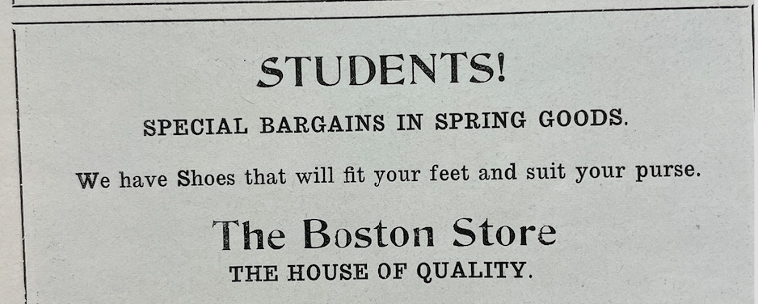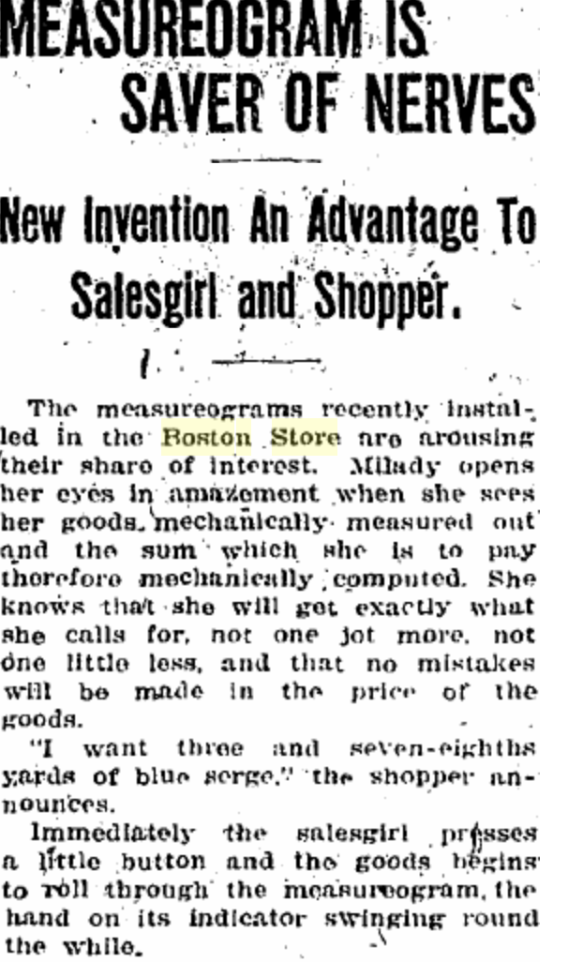
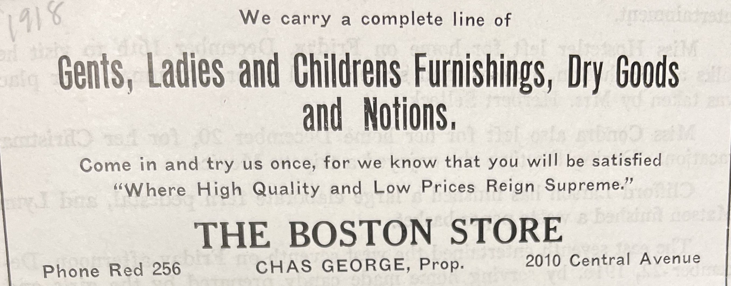
*Photos were acquired from local yearbook advertisements and the Kearney Hub (3/3/19)

