The Kearney Flour Mill opened in the 1890s in Kearney, NE. It was located at S. RR St. and A. It closed in the 1920s. According to Kearney Historic Homes, Rollin L. Downing was the owner and creator of the mills. He was also the president of the Kearney National Bank. Other owners found within the BCHS archives and a 1902 Kearney Hub article were J.J. Bartlett and F.F. Roy. Its advertisement is located on the Kearney Opera House curtain.
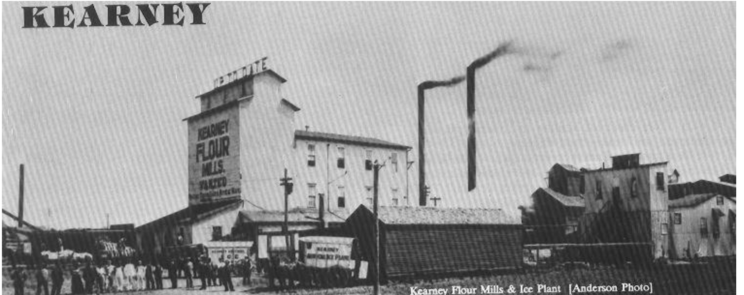
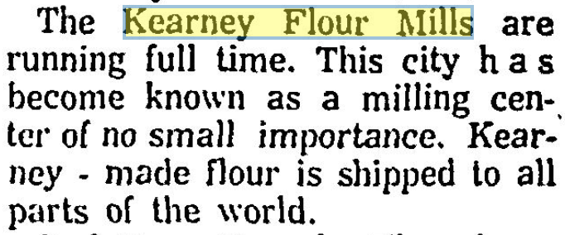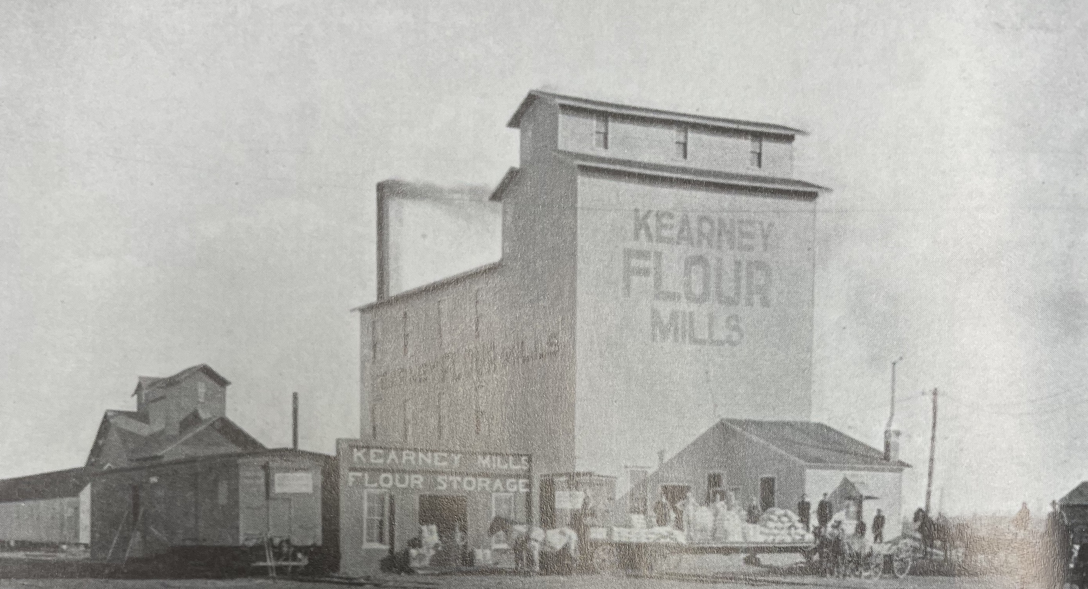
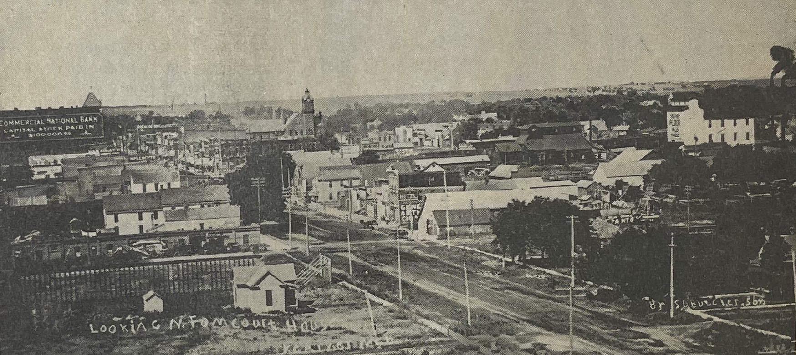

*Photos taken from the Kearney Hub (8-13-1902), (10-1-1963) and Kearney Historic Homes (Whetstone, Harris and BCHS)

