Kearney Plumbing and Heating Company was a popular business in Kearney, NE. The founders were Bert Wallace, Waldron Lunger and Carl Backers, who founded the business in the 1920s. According to the Kearney Hub, in 1950 their motto was, “When you need a plumber bad, you need him good.” (3-21-1950). Its advertisement can be seen on the Kearney Opera House and the World Theatre curtains!
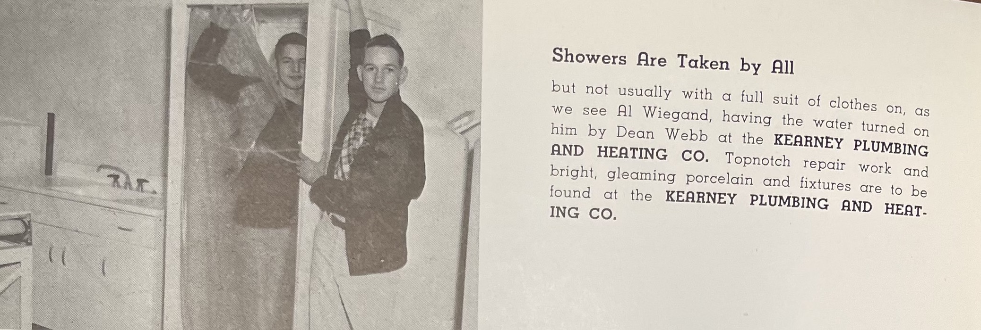
(Log: 1949)
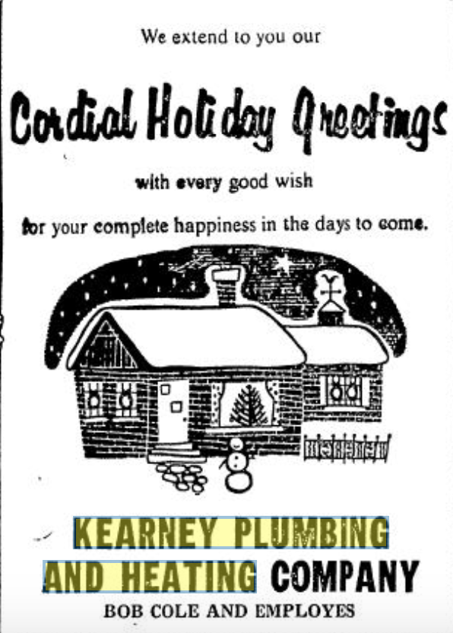
(Hub: 12/24/1959)

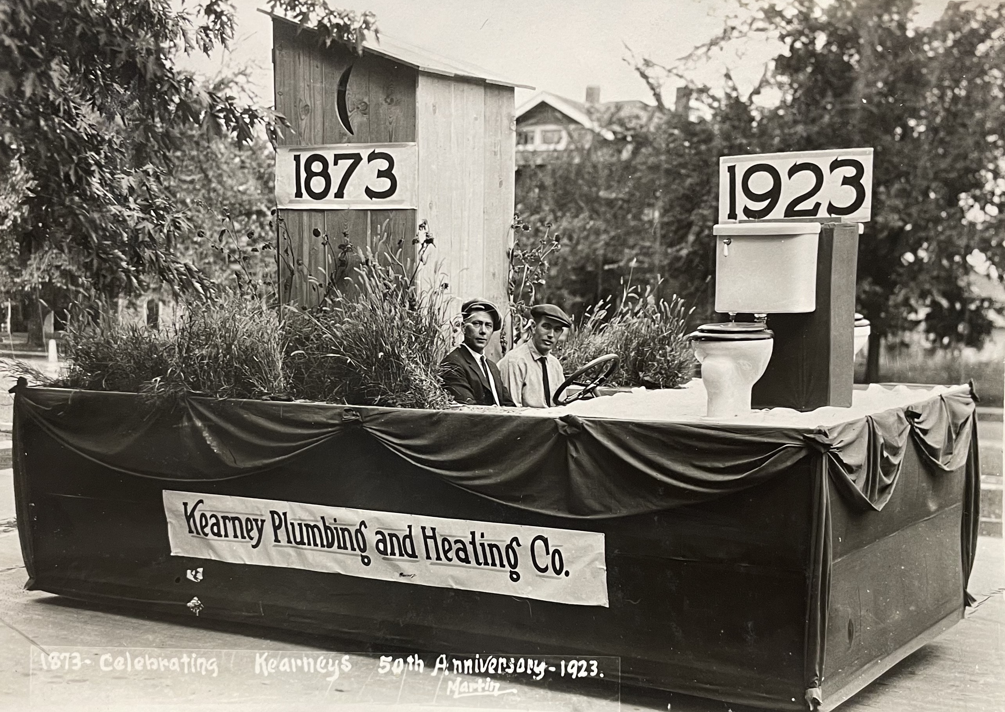
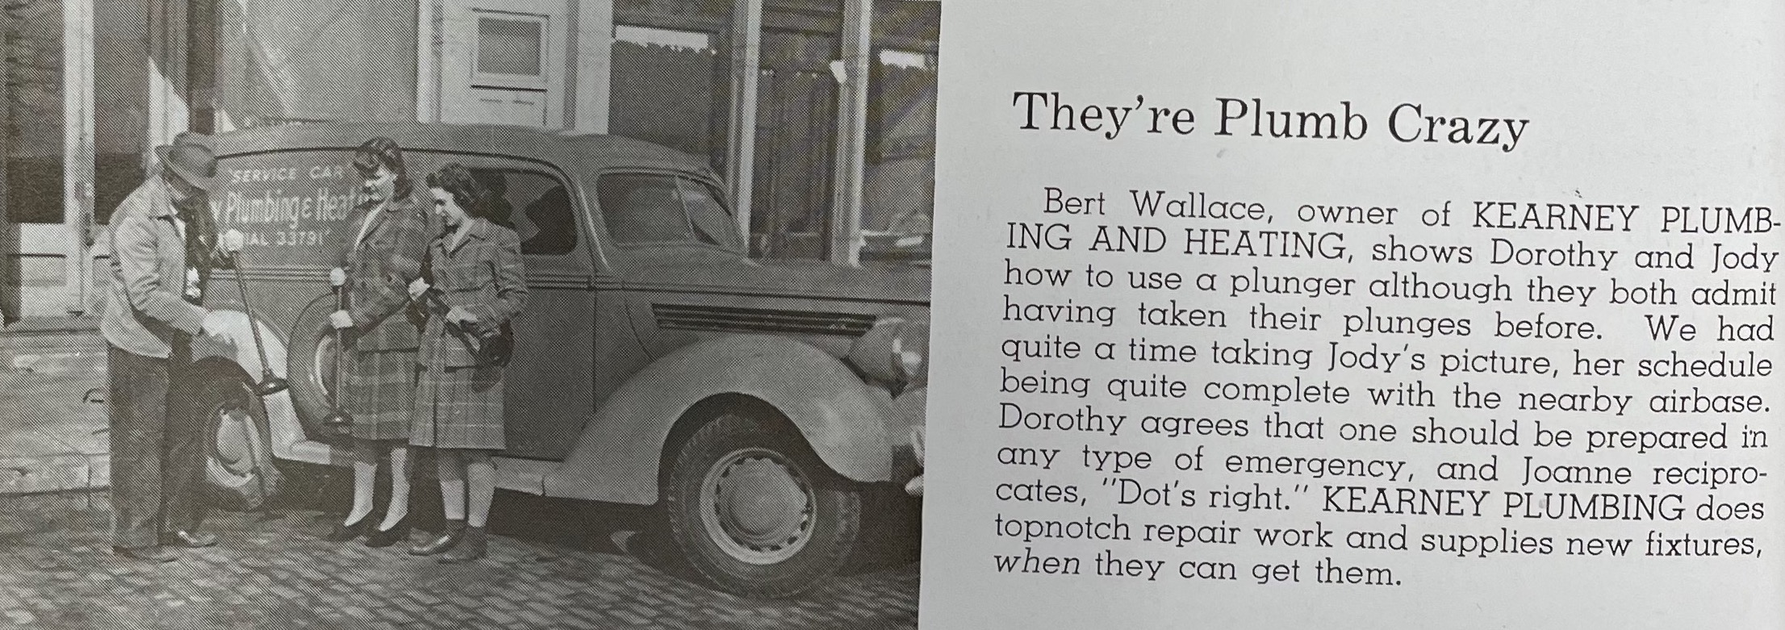
(Log: 1943)

