Ayers Clothing was a popular clothing store in Kearney, NE. It was located at 2201 Central Avenue. People of all types were able to find attire for all occasions. Its advertisement is located on the Poole School curtain.
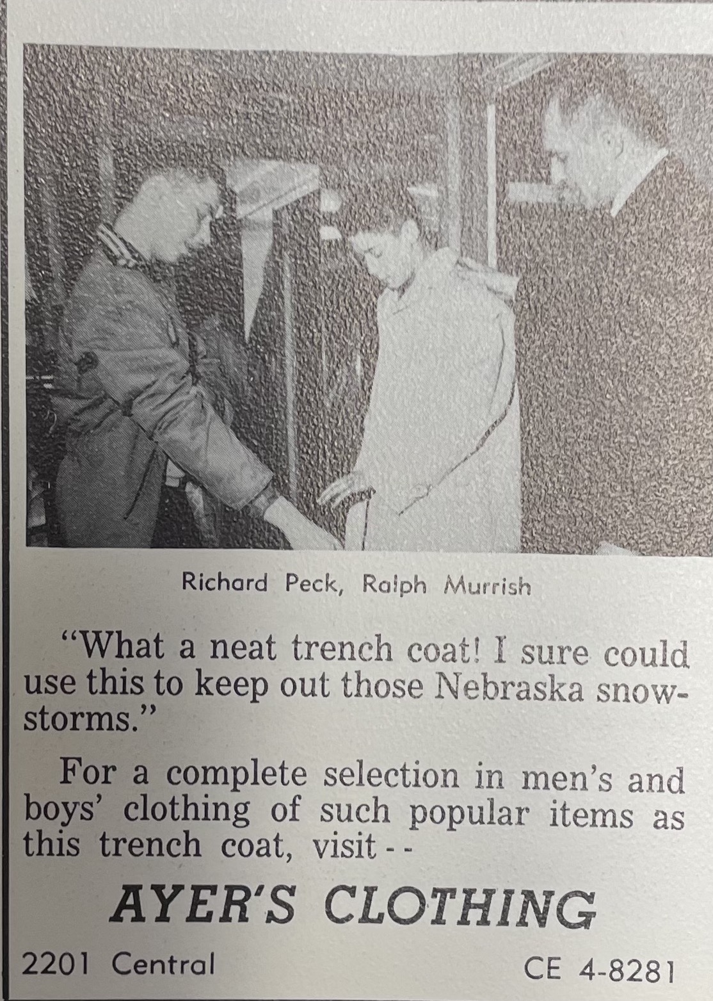
(Log: 1960)
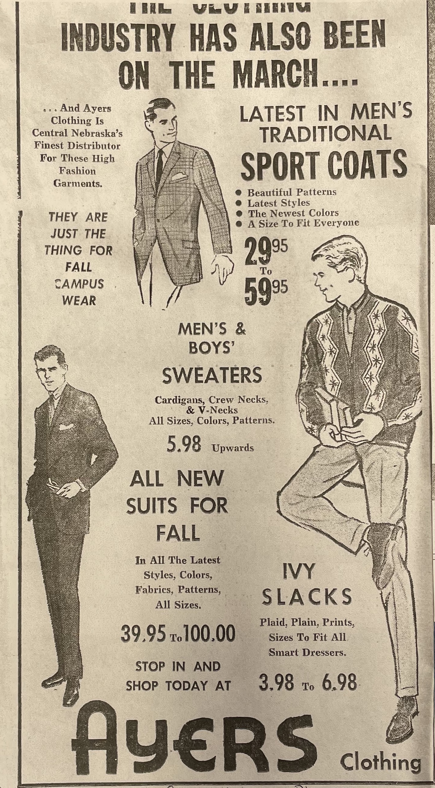
(Kearney Hub: 9-24-1963)

