The Farmer’s State Bank was a popular local bank in Kearney, NE. Its advertisement is located on the Kearney Opera House curtain.
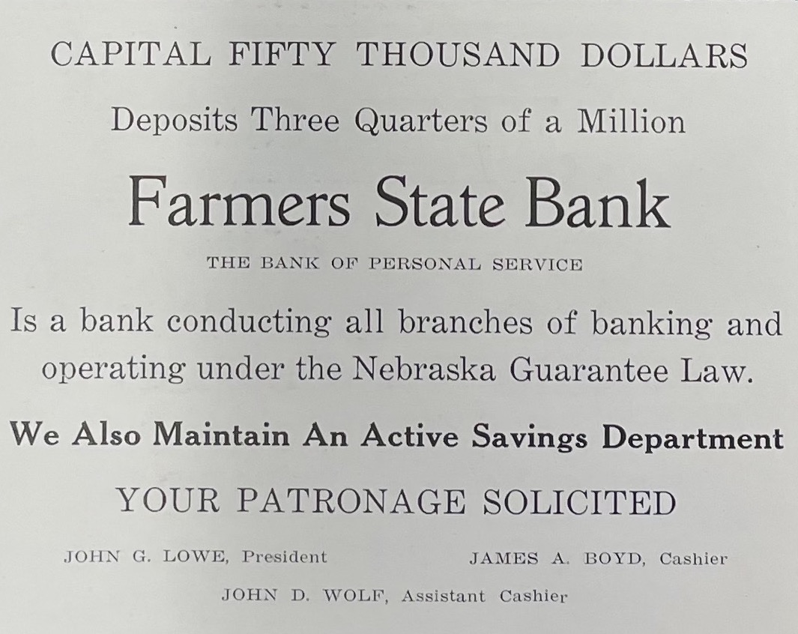
(Kearney High School Annual: 1921)

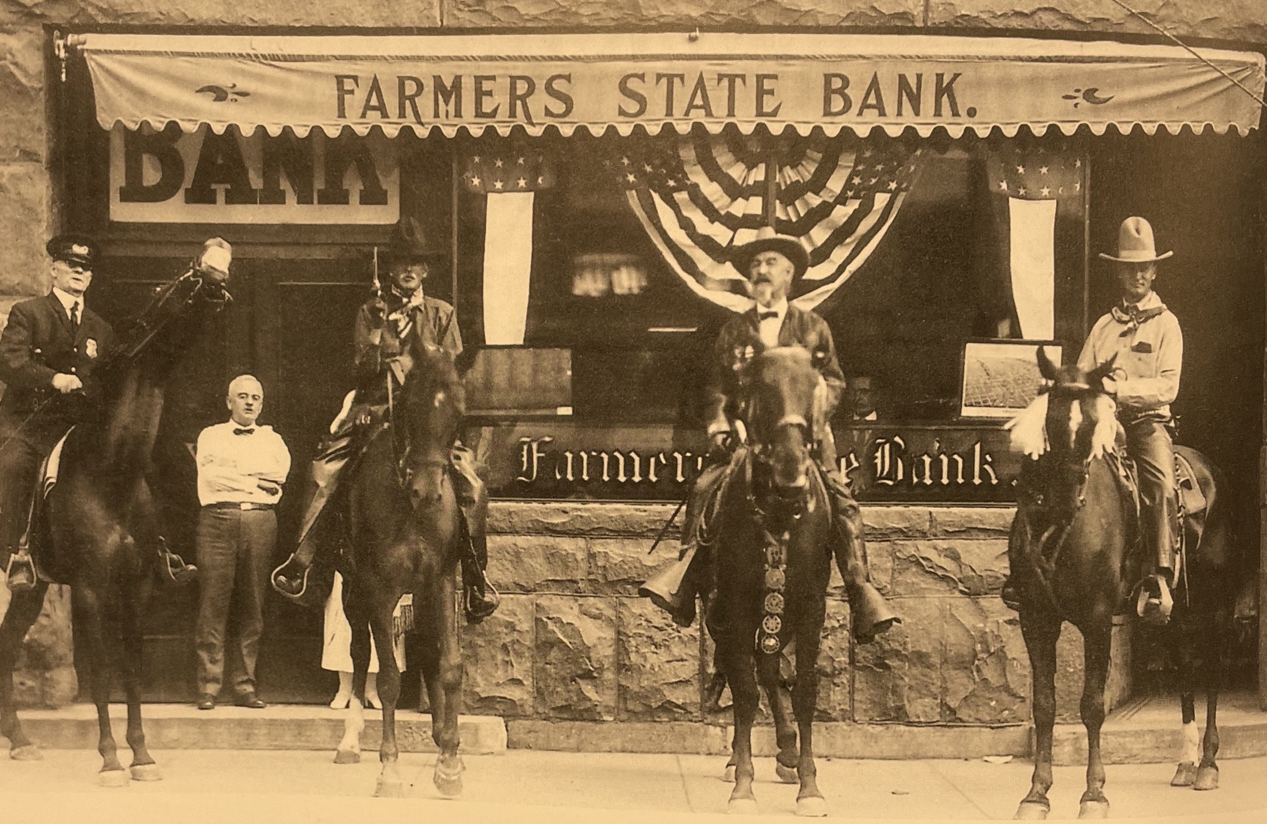(circa 1908)
(Kearney Memories-Kearney Hub)

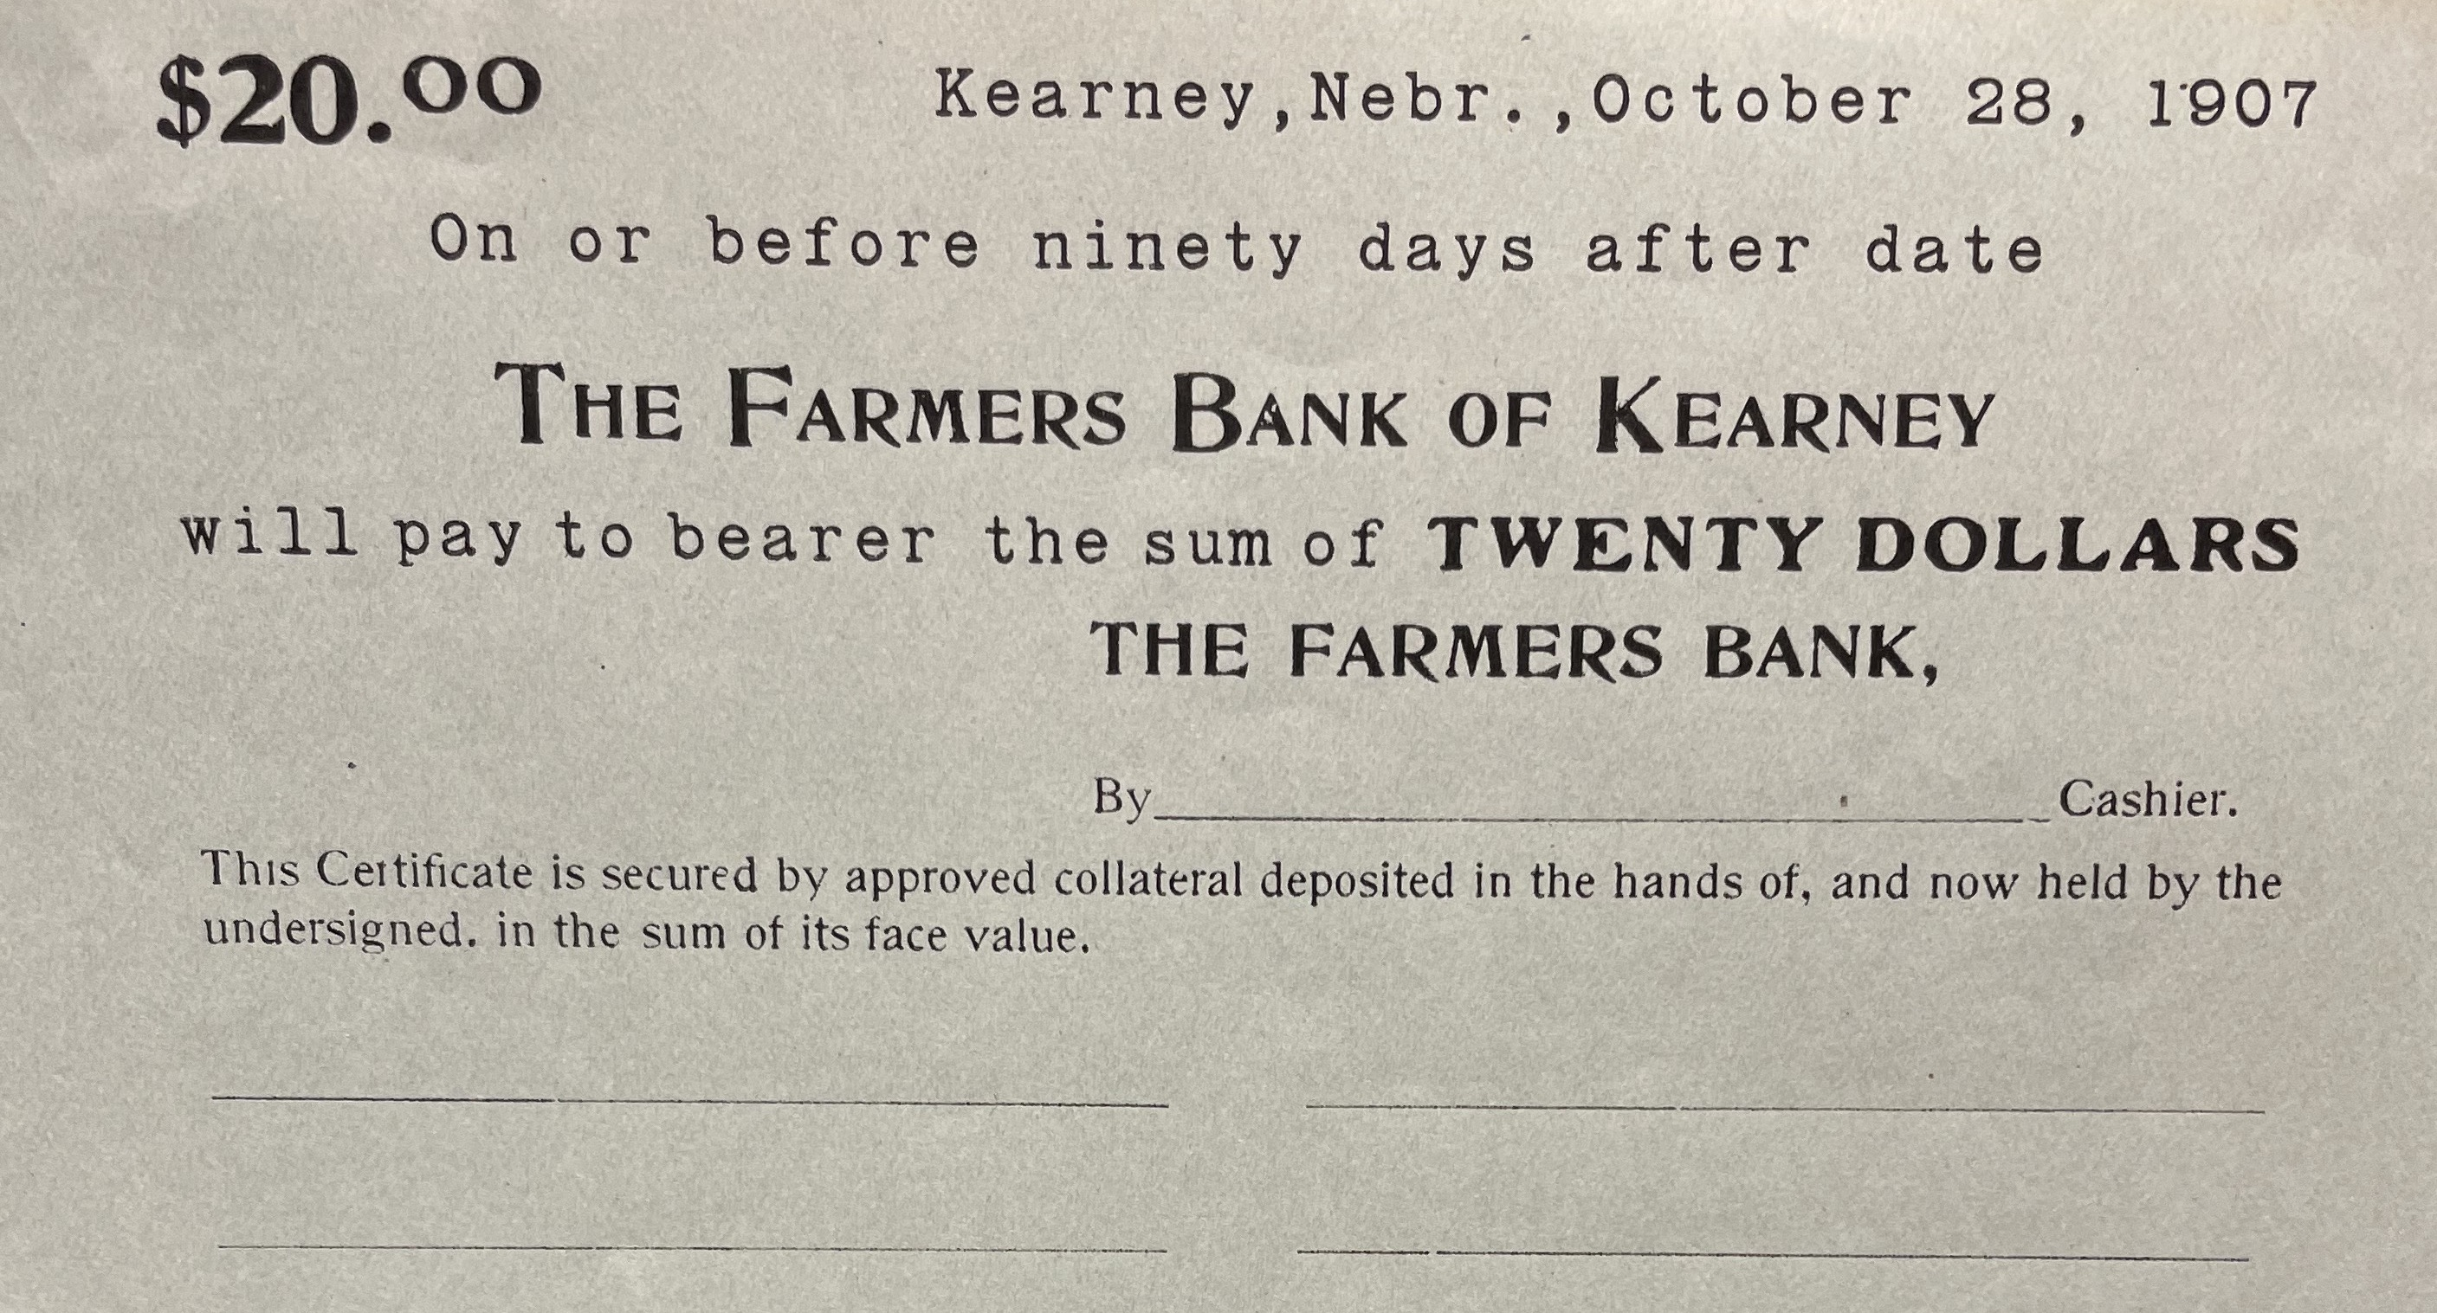
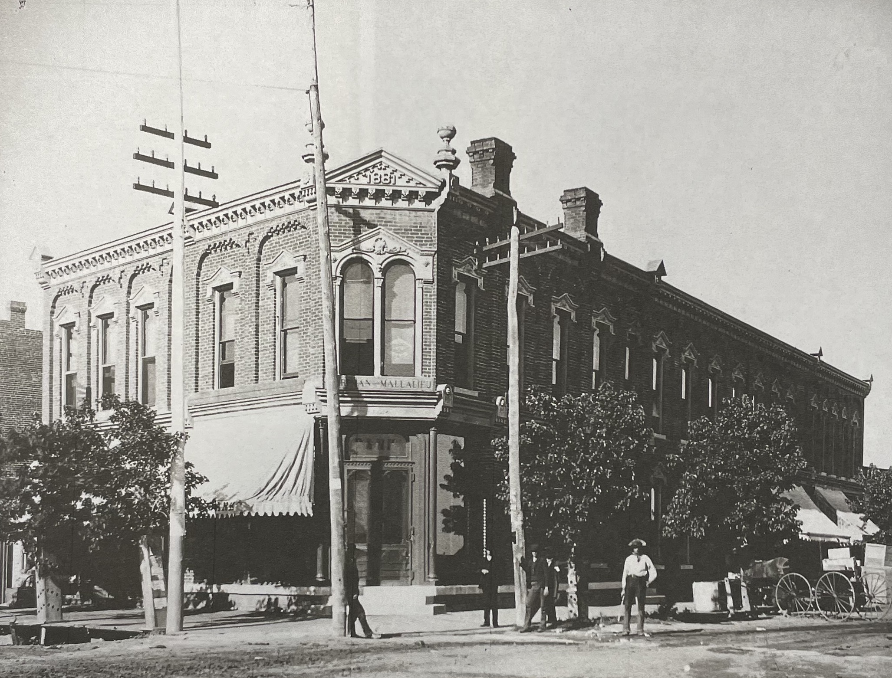
(Hub)

