The First National Bank was located in Kearney, NE. Its advertisement can be seen on the Kearney Area curtain.
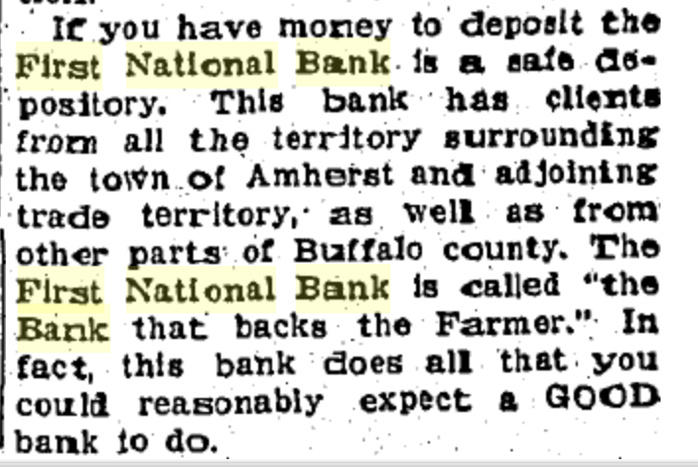
(Hub: 7/20/1933)

