Gambles was a store that was located in Kearney and Ravenna, NE. It doors opened in 1930. There are plenty of advertisements displaying the variety of goods offered by this business. Its advertisement can be seen on the Poole School curtain.
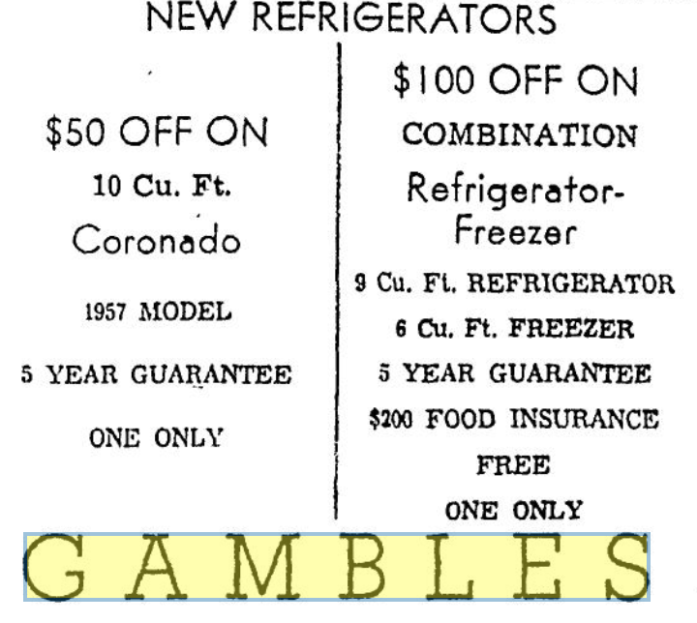
(Hub: 1-8-1958)
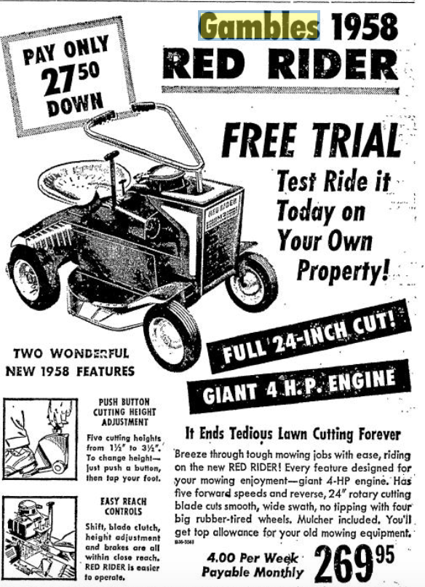
(Hub: 4-25-1958)

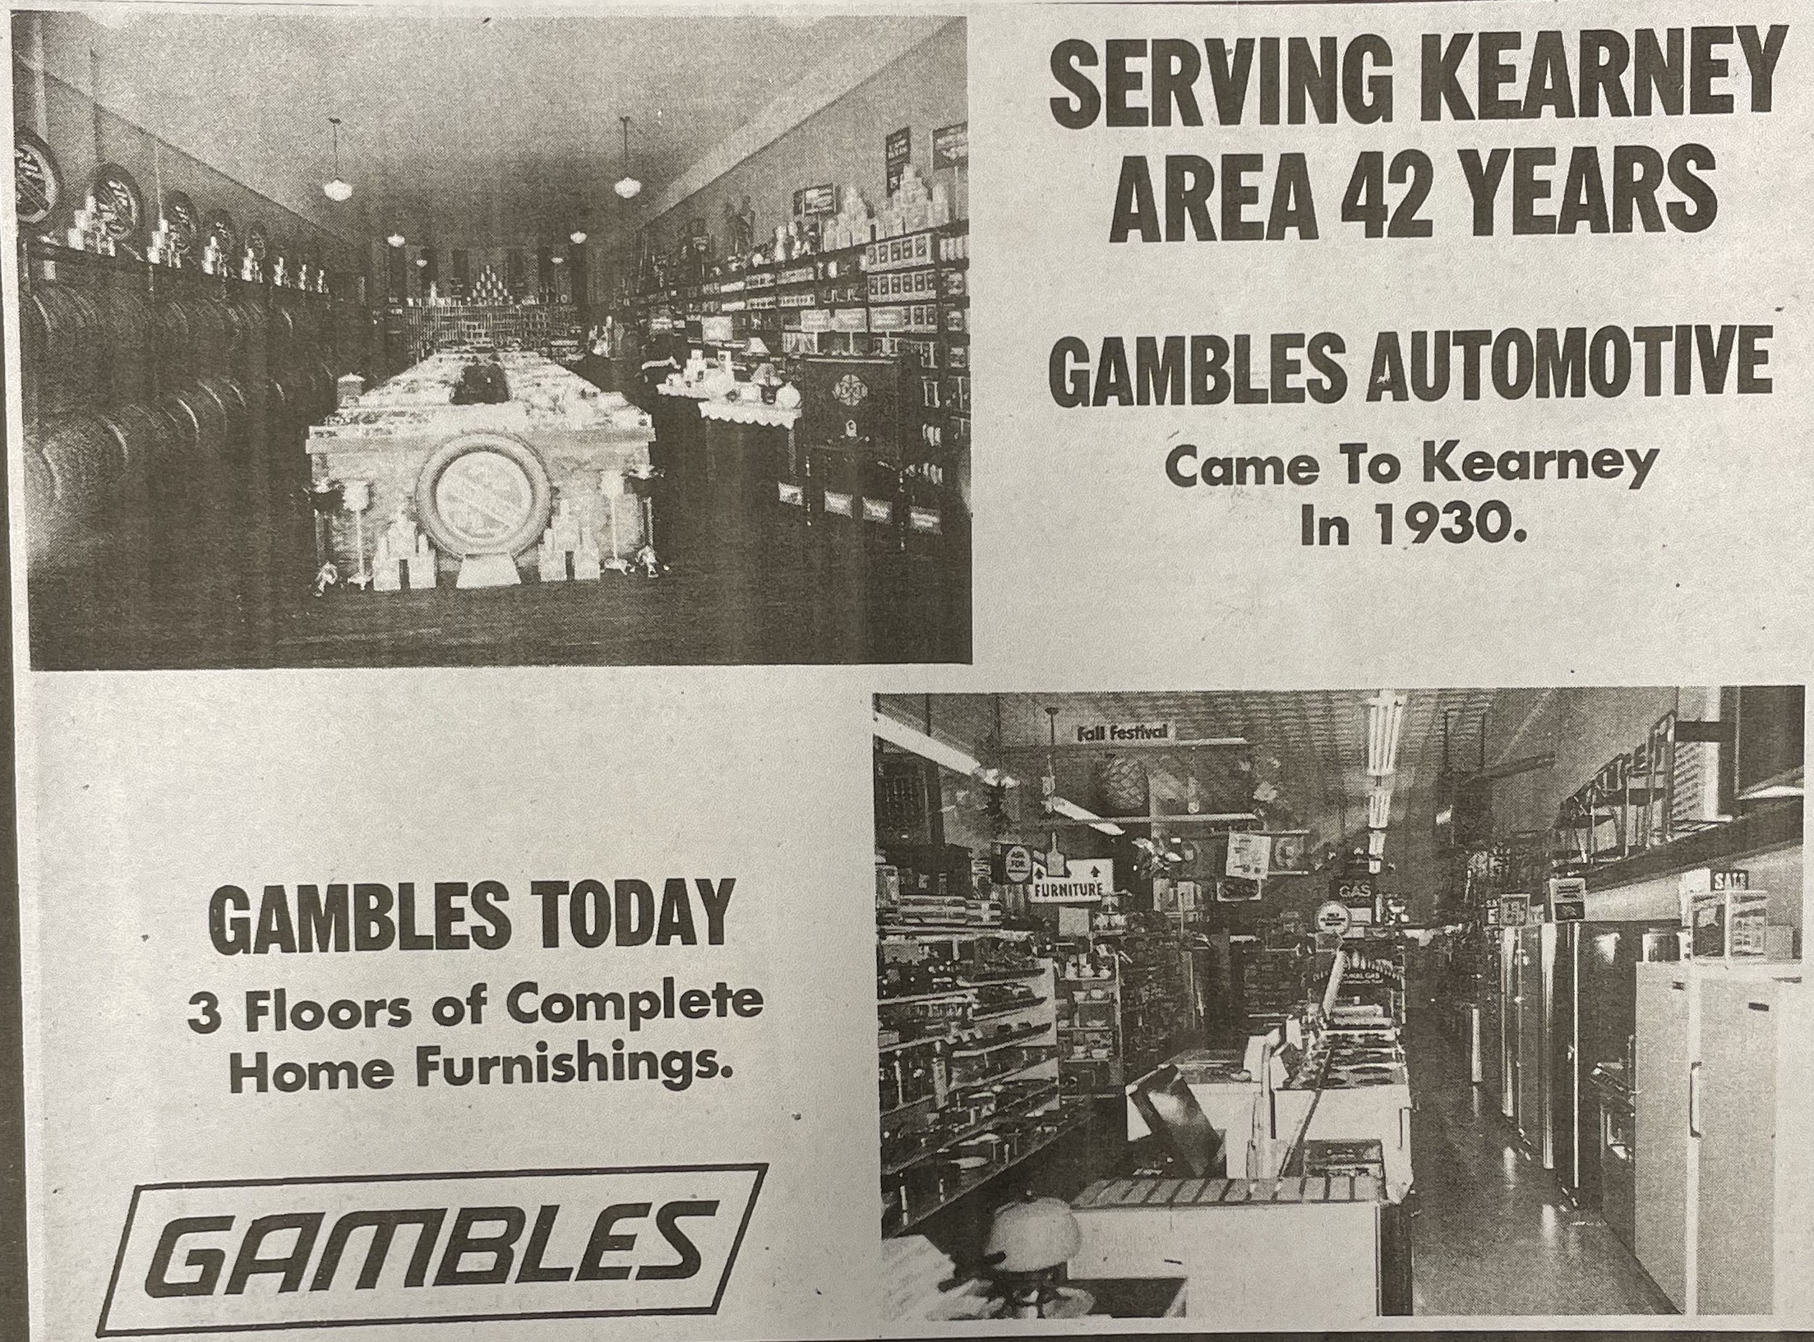
(Hub: 9-17-1963)

